How Eyes Evolved – Analyzing the Evidence

We depend on our eyes for detailed information about the world around us. Octopuses also depend on their eyes, e.g. to find the prey they eat. Both human eyes and octopus eyes have multiple parts that work together to provide detailed visual information to the brain. Both types of complex eyes have:
- a similar overall shape and structure
- a lens which focuses light to form an image on the retina
- a retina with many photoreceptor cells.
Photoreceptor cells contain molecules that respond to light (light-sensitive molecules). The signals from photoreceptor cells are processed by the nervous system.

1. In the diagram of the human eye:
- Show where the photoreceptor cells are located.
- Use an arrow to show how light enters the eye and reaches the retina.

In this activity, our main questions will be:
- How could something as complex as the human eye or the octopus eye have evolved by natural selection?
- How can scientists learn about the evolution of eyes, since there is very little fossil evidence?

To begin, we will review natural selection. As a result of natural selection, an adaptive, heritable trait becomes more common in a population.

2a. Define a heritable trait.

2b. Define an adaptive trait.

2c. Whether a trait is adaptive depends on the habitat and general life style of an animal. Give an example of a trait that is adaptive for an animal in one habitat, but not adaptive for a different animal in a different habitat.

2d. Explain why an adaptive heritable trait becomes more common in a population.

To demonstrate one step in natural selection for a better lens, imagine a population of octopuses where almost all the octopuses have the genotype (ii) which results in a lens that produces fuzzy images. A mutation has occurred, so one octopus has a new allele (I) that results in a better lens that produces sharper, clearer images. (Assume that the I allele is dominant relative to the i allele.)
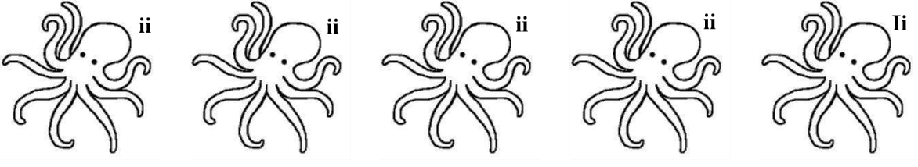
3a. Circle the octopus that would be most likely to survive and reproduce. Explain why that octopus would have an advantage.

3b. Think about the next generation of octopuses. Would you expect the percent of octopuses with an I allele to decrease ___ increase ___ stay the same ___?

3c. Explain the reason for your prediction.

This example illustrates how natural selection can result in small improvements in vision. In the following sections, we will explore how natural selection for multiple small improvements in vision could eventually result in the complex eyes of humans or octopuses.

Evidence from Comparative Anatomy
To develop hypotheses about the evolution of complex eyes, scientists have studied the anatomy and function of different types of eyes in a variety of animals alive today. None of these living animals was an evolutionary ancestor of humans or octopuses. However, the different types of simpler eyes in some living animals can suggest a possible sequence of intermediate steps that may have occurred during the evolution of the human eye or octopus eye. Additional information about these living animals indicates how each intermediate step could have been useful and contributed to increased fitness (the ability to survive and reproduce).

4. Scientists believe that the early evolutionary ancestors of modern animals had an eye spot, a small group of photoreceptor cells that can detect light vs. dark. How could an animal benefit from having an eye spot (compared to not having any type of light detector)?

Light-Sensitive Sensory Organs in Several Types of Living Animals
Eye spot
(e.g. in a limpet that scrapes algae off of rocks and glides or creeps along, similar to a snail)
Eye cup  (e.g. in a snail that feeds on sponges and moves by gliding or creeping along) |  | 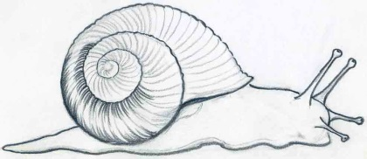
Complex eye  (e.g. in an octopus, an active predator that relies on vision to hunt prey; it moves by swimming or using its arms for crawling.) |  | 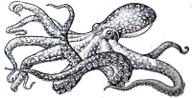

Each type of light-sensitive organ can be useful for the animals that have it. For example, eye spots which detect light vs. dark are useful for limpets that are active at night and not active during the day. When the limpet's eye spots detect light, the limpet clamps its conical shell down on the rock to avoid predation and drying out during the day.

One advantage of an eye cup is that the shape of the eye cup allows an animal to detect which direction light is coming from. Your answers to question 5 will explain why an eye cup can detect which direction light is coming from, but an eye spot cannot.

5a. In both figures below, use arrows to show the path of light coming from the upper left and circle the photoreceptor cells that would be stimulated by light coming from the upper left. Use dashed arrows to show the path of light coming from the upper right. (Remember that light travels in a straight line.)

Eye Spot |  | Eye Cup

5b. What information from an eye cup can be used to tell whether light is coming from the left or from the right?

5c. Why can’t an eye spot provide information about what direction the light is coming from?

5d. Suggest one way that a snail with an eye cup could benefit from being able to detect which direction light is coming from.

During their early evolution, animals lived in water. In water, if an eye has no lens, then light continues in a straight line, as shown in the figure on the left. Notice that light waves from the circle on the left and the square on the right stimulate different parts of the retina. However, light waves from the three shapes in the middle can all stimulate the same photoreceptor cell in the retina.

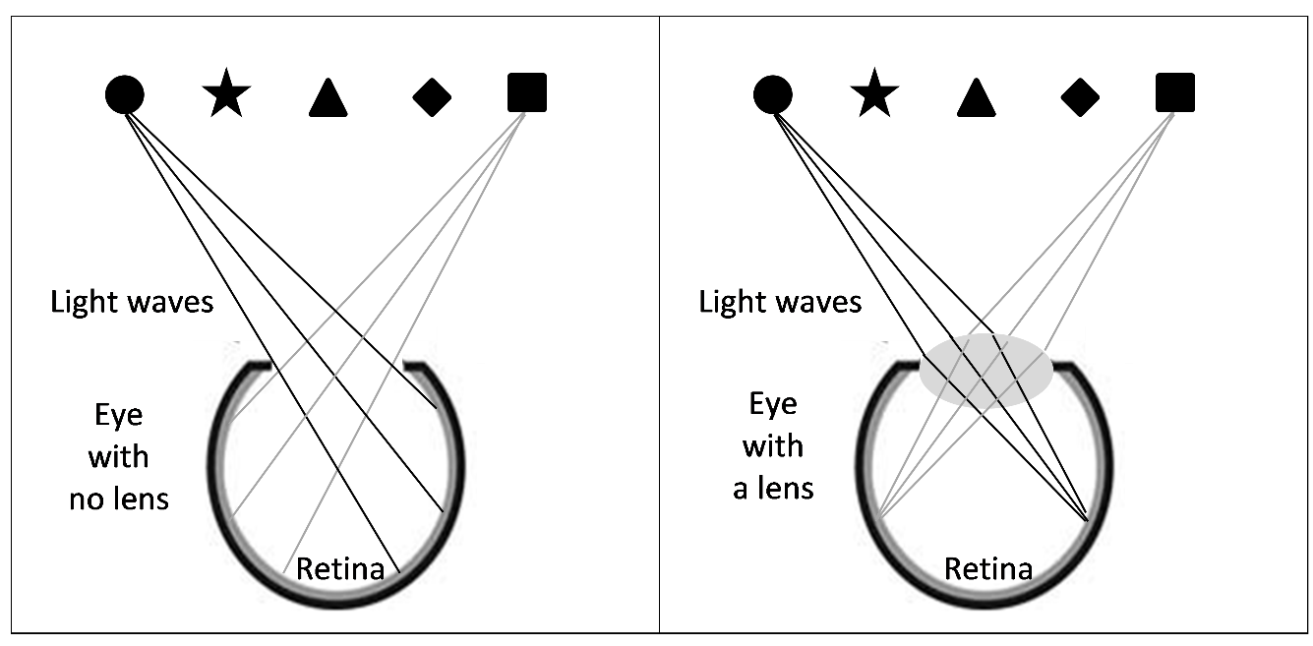

6. In the diagram of the eye with no lens, draw straight lines to show how light waves from the circle, star and triangle can all stimulate the same photoreceptor cell in the retina.

In the eye with no lens, each photoreceptor cell receives light input from multiple points in the environment. Thus, the image on the retina in an eye with no lens would be very blurry.

In contrast, a lens can bend light so each photoreceptor cell in the retina receives light input from only a single point in the environment. Thus, an eye with a lens can provide more detailed and accurate visual information than the same shaped eye without a lens.

7. Explain why natural selection favored the development of a lens in octopus eyes.

A Mathematical Model
The evidence from comparative anatomy suggests the hypothesis that, during evolutionary history, eye spots evolved to eye cups which evolved to complex eyes with lenses. Each step in this proposed evolutionary sequence provided additional visual information that could help the animals to survive and reproduce.

To test the plausibility of this hypothesis, scientists developed a mathematical model that mimicked natural selection. For each generation in this mathematical model, there were small random variations in the model eye (mimicking the effects of random mutations), and selection favored any changes that resulted in improved ability to provide detailed visual information.

This mathematical model began with a flat three-layer structure (shown in the upper left of this figure).
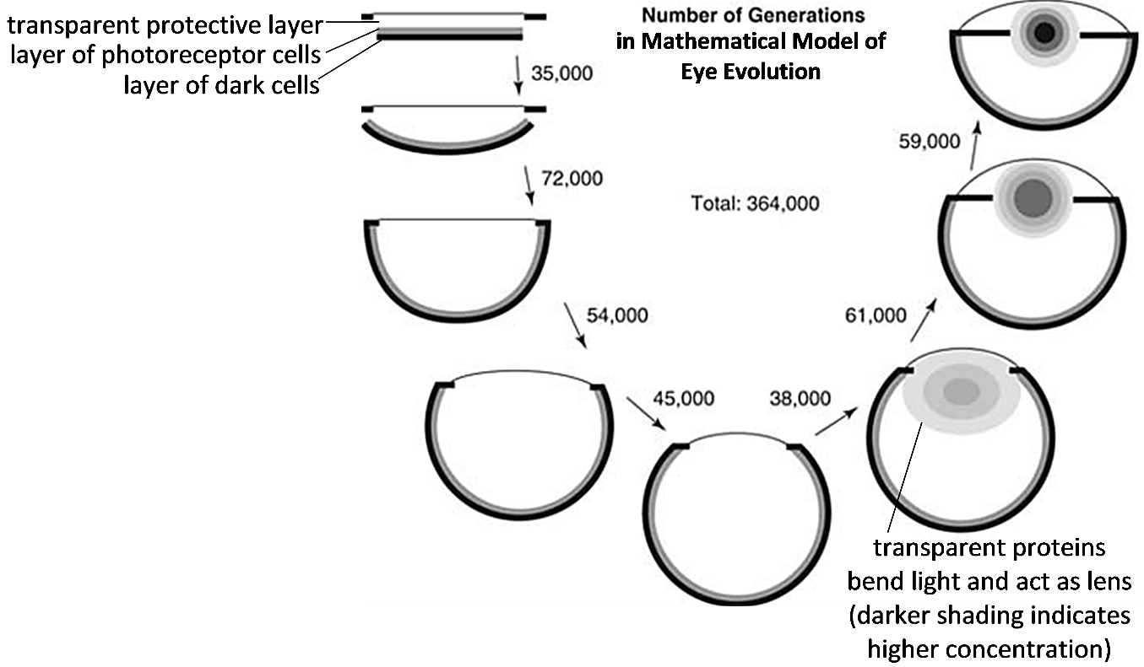

The figure shows that, in the early generations in this mathematical model, selection for improved ability to provide more detailed visual information resulted in increasing curvature of the layer of photoreceptor cells (shown on the left). Then, after 200,000 generations, continued selection resulted in increasing concentrations of transparent proteins in the opening where light entered the eye (shown on the right). As the concentrations of transparent proteins increased, these proteins acted as a better lens, bending light waves to produce a more focused image on the layer of photoreceptor cells.

8a. This mathematical model began with a model eye that resembles an _______________.
(eye cup / eye spot)
8b. The third model eye on the left shows the results of 107,000 generations of selection for more detailed visual information. At this stage the model eye resembles an ________________.
(eye cup / eye spot)
8c. The right side of the figure shows how continued selection produced increasing concentrations of transparent proteins that bend light and act as a _______________ .
(retina / lens)

9. After 364,000 generations of selection for improved ability to provide more detailed visual information, the model eye resembled a complex human or octopus eye. In the final model eye (shown in the upper right in the figure), label the structures that correspond to the retina and the lens of a complex eye.

10a. Scientists estimate that during the evolution of eyes, each generation corresponded to approximately one year. Based on this mathematical model, could natural selection have operated quickly enough to produce the complex eyes of octopuses and vertebrates in the 500 million years of animal evolution? yes ___ no ___
10b. Explain your reasoning.

Molecular Evidence
Scientists can estimate when in evolutionary history a protein first originated by evaluating molecular similarities and differences in living animals. For example, if a protein and the gene that codes for it are similar across a broad range of living animals, this indicates that all these groups of animals probably inherited this gene from a common ancestor that lived a very long time ago during the early evolution of animals.

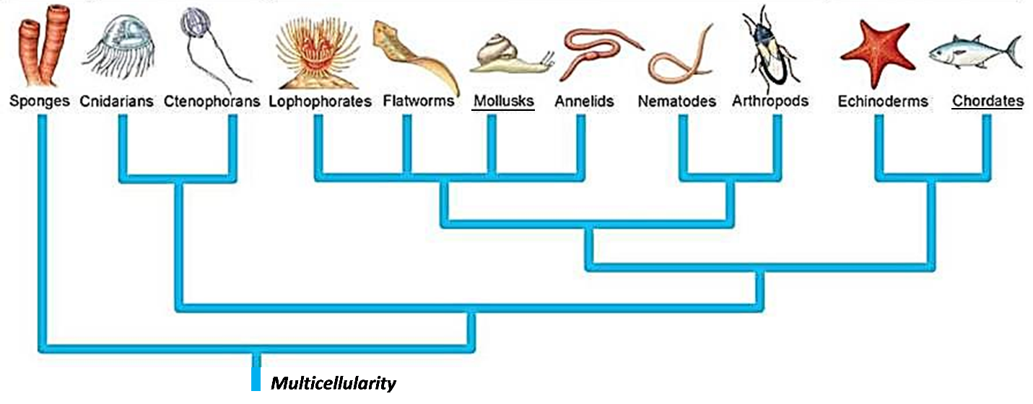
This figure shows the major phyla of contemporary animals and their evolutionary relationships. Octopuses, snails and limpets belong to the Mollusk phylum. Humans and other vertebrates belong to the Chordate phylum.

Evolutionary events that occurred earlier are shown lower down in the figure. For example, multicellularity evolved at the very beginning of the evolution of the animal kingdom and all contemporary animals are multicellular. Also, the evolutionary ancestors of sponges diverged from the evolutionary ancestors of all other animal phyla very early in animal evolution.

Light-Sensitive Molecules in Photoreceptor Cells
- In all types of animals except sponges, photoreceptor cells in the retina have a similar type of light-sensitive molecule that combines an opsin protein with a molecule like retinal (a form of vitamin A).
- All types of animals except sponges have one or more genes for an opsin protein.
- The similar nucleotide sequence of these opsin genes and additional molecular evidence indicates that all the contemporary opsin protein genes are descended from an opsin protein gene that evolved very early in the evolutionary ancestors of all animals except sponges.

11. Write opsin in the appropriate location in the above figure to show when light-sensitive molecules with opsin proteins first appeared in animal evolution.

Transparent Proteins in the Lens
- Different types of animals have very different types of proteins in the lens of their eyes. For example, the octopus eye and the human eye have very different proteins in the lens.
- Although octopus eyes have a lens with lens proteins, many other Mollusks have eye spots or eye cups with no lens or lens proteins.

12a. Based on this evidence, do you think that lens proteins evolved:
___ in the shared evolutionary ancestors of Mollusks and Chordates?
___ more recently during the separate evolutionary histories of octopuses and Chordates?
12b. Explain your reasoning.
Conclusions
13. Summarize two different types of evidence that support the conclusion that photoreceptor cells evolved before lenses evolved.

14a. If an ancient animal ancestor had an eye spot, how could natural selection over many generations have resulted in a series of small changes that led to the evolution of an eye cup in an evolutionary descendent?

14b. Explain how continued natural selection for improved vision could have produced a series of small changes that resulted in a lens that bends light.

15. Complete this table to present a scientific argument for the claim that:
“Over many generations, the complex octopus eye probably evolved from a simple eye spot in the evolutionary ancestors of all animals except sponges.
Evidence | Reasoning
Comparative anatomy

Mathematical modeling

Molecular analyses

By Dr. Ingrid Waldron, Department of Biology, University of Pennsylvania, © 2022. A Word file for this Student Handout and Teacher Notes with background information and instructional suggestions are available at http://serendipstudio.org/exchange/bioactivities/evoleye.

